AIM: Demonstrate the use of Matplotlib library

Matploitlib is a Python Library used for plotting, this python library provides and objected-oriented APIs for integrating plots into applications.
matplotlib.pyplot is a plotting library used for 2D graphics in python programming language.It can be used in python scripts, shell, web application servers and other graphical user interface toolkits.Matplotlib is not a part of the Standard Libraries which is installed by default when Python.
import matplotlib.pyplot as plt
plt.plot([1,2,3],[5,7,4])
plt.show()
# importing matplotlib module
from matplotlib import pyplot as plt

# x-axis values
x = [5, 2, 9, 4, 7]

# Y-axis values
y = [10, 5, 8, 4, 2]

# Function to plot
plt.plot(x,y)

# function to show the plot
plt.show()
Output :
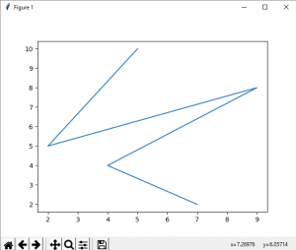
Bar plot :

# importing matplotlib module
from matplotlib import pyplot as plt

# x-axis values
x = [5, 2, 9, 4, 7]

# Y-axis values
y = [10, 5, 8, 4, 2]

# Function to plot the bar
plt.bar(x,y)

# function to show the plot
plt.show()
Output :
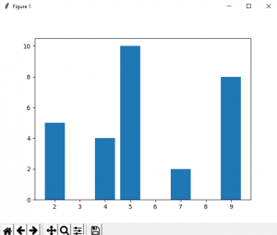
Histogram :

# importing matplotlib module
from matplotlib import pyplot as plt

# Y-axis values
y = [10, 5, 8, 4, 2]

# Function to plot histogram
plt.hist(y)

# Function to show the plot
plt.show()
Output :
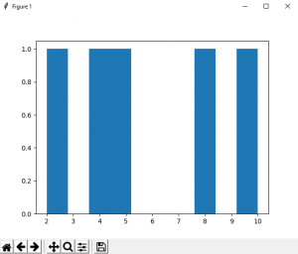
Scatter Plot :

# importing matplotlib module
from matplotlib import pyplot as plt

# x-axis values
x = [5, 2, 9, 4, 7]

# Y-axis values
y = [10, 5, 8, 4, 2]

# Function to plot scatter
plt.scatter(x, y)

# function to show the plot
plt.show()
Output :
